OneVA Pharmacy Implementation

**Meeting Information**

|  |  |  |  |
| --- | --- | --- | --- |
| **Discussion:** | OneVA Pharmacy Implementation Daily Scrum Meeting | | |
| **Date of Meeting:** | 10/21/2015 | **Location:** | Teleconference |
| **Facilitator:** | Sherri Simons | | |
| **Time:** | 2:30pm-3:00pm | | |

|  |  |  |  |
| --- | --- | --- | --- |
| Attendee Name (P=Present) | | | |
| Brad Fisher | **P** | Birali Hakizumwami |  |
| Sherri Simons | **P** | TJ Cope | **P** |
| Sue Stephens | **P** | Tom Bigelow | **P** |
| Tony Burleson | **P** | Josh Temkin |  |
| Kathy Coupland | **P** |  |  |

**Business Action Items Outstanding**

| Action Item Origination Date | Action Item | Owner | Status | Closed Date *closed items will roll off in 48-hrs |
| --- | --- | --- | --- | --- |
| 10/20/2015 | Meeting with the VA to discuss:   * Local Refills * Controlled Substances across state lines * Alternate Matching * Locking   Questions: How are local controlled substances identified today? What filter logic to use for controlled substance? | Sherri | Open |  |
| 10/21/2015 | Brad needs access to upload POC/Pilot Build. | Sherri | Open |  |

**Internal Team Action Items Outstanding**

|  |  |  |  |  |
| --- | --- | --- | --- | --- |
| Action Item Origination Date | Action Item | Owner | Status | Closed Date *closed items will roll off in 48-hrs |
| 10/20/2015 | Reschedule Daily Scrum Meeting using Skype Teleconferencing 2:30:2:45. | Sherri/ Cecilia | Open |  |
| 10/20/2015 | Update CPMP with TJ’s deliverable matrix and build out milestone deliverables. | TJ/Sherri/ Cecilia | Open |  |
| 10/20/2015 | Base year project artifacts (e.g. test plans) retrieved. | Sherri/Josh Temkin | Open |  |
| 10/20/2015 | Develop Team Collaboration Site on The BITS Group SharePoint. | Sherri/Zach | Open |  |
| 10/21/2015 | Use Case for Controlled Substances – Follow up with Birali when he returns to received feedback. | Sherri | Open |  |

| **Discussion Notes** |
| --- |
| * Tony stated that SRA was able to use Skype Business. Kathy followed by sharing she tested with The BITS Group Help Desk and it is available for BITS also.   + Brad mentioned 2:30 might work best for Birali as opposed to 2 pm.   + Action Item: Sherri to discuss with Cecilia. * Sherri is meeting with the Health Data Repository (HDR)/Corporate Data Repository (CDR) group at noon on Oct 22nd to provide a OneVA Pharmacy Road Show presentation with Mr. Patterson. TJ and Brad will join. * As first deliverable due Friday October 30th the POC/Pilot build needs to be uploaded.   + Action Item: Brad to get access and upload * TJ shared he created a deliverables matrix and wondered if he would be working with Cecilia to firm up the Contractor Project Management Plan (CPMP) to firm the schedule.   + Action Item: Sherri to discuss with Cecilia on Monday * Tom and Tony provided their questions in the form of an Email after the meeting. Please read below. * Kathy reported she is working on the build out of the initial RSD that TJ turned over to her. |
|  |

**Additional Notes sent after the meeting from Tony and Tom:**

1. How many Prescription Managers are there? Is there one Prescription Manager per MTF or is there only one central Prescription Manager for all MTFs? The SDD wording seems to indicate a single manager for all MTFs in some cases, many managers in others. Figure 1 below depicts both options. A deployment diagram would be really nice to have.
2. Is the Prescription Manager stateful (meaning does it have a dedicated database only it connects to)?
3. When the “Provides Remote Orders” sub-use case executes, is this a broadcast to all VistA instances?
   1. How does the Prescription Manager “know” the addresses of all the MTFs? (it is a “Proxy to remote VistAs” [see SDD section 3.3])
   2. Who manages those lists of active MTFs?
   3. Does a timeout (i.e. no response) mean the MTF’s network connection is down? If that down remote MTF has an active prescription, how would the requesting system know?
4. In the “View Orders” use case, step 4 states, “The Prescription Manager system will retrieve the prescriptions from ***all previous treatment facilities*** [of the patient] excluding local facility.” (Emphasis added). Where is that information stored?
5. The GitHub project generates several artifacts. Two WAR-files and two JAR-files. The PharmacyManager.war is the prescription manager. Where is the LLPRouter.war deployed? Section 2.2 of the SDD only lists the entities and their responsibilities.
6. What version control system are we using?
7. What task management system are we using?
8. Are we using a continuous build system?
9. I saw the code referencing J2EE containers; is there any constraints on the vendor and/or version (e.g. Apache TomEE 1.7.2)?
10. Since this effort leads into a production deployment, that means install scripts and instructions are needed correct? Is there any pre-existing mechanisms for this?
11. Where is our development environment?
    1. Do we create a local development environment?
    2. Does the VA provide that for us?
    3. Is that a sandboxed environment where we can perform multiple deployments per hour?
    4. How long does it take to get that access?
12. From the contact list, it seems there is only one Java developer (me) and one VistA developer (Brad Fisher). Is that correct?

I am still very unclear what work needs to happen on the Java side. I see a Jim Horner’s name in the Java code. Is he still accessible for questions if needed?

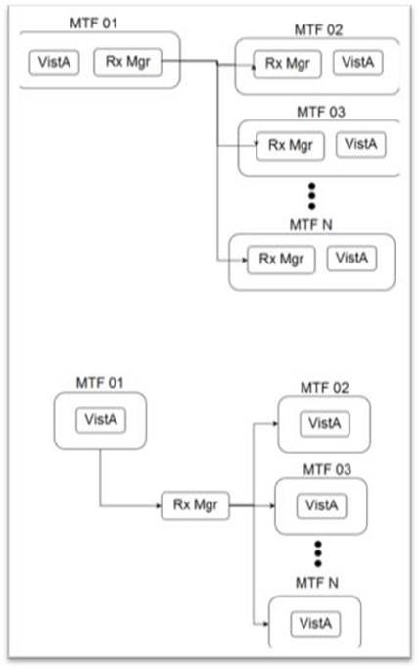

Figure 1: Two options showing the relationship between the Perscription Manager and VistA instances